

UI Test Suite Installation Manual

**Fusion VMC 2.0**

Contents

1.Pre-requisites: 3

1.1 Pre–requistes to run TestScripts: 3

2. Configuring The Test Suite: 3

2.1 Steps to be updated in Input Sheet before Execution: 3

2.1.1 VMC2Info Sheet: 3

2.1.2 TestScope Sheet: 4

2.1.3 Description of Columns in InputSheet: 5

3. Installation – Linux: 5

3.1 Steps to install maven in Linux (Ubuntu): 5

3.2 Steps to Build the Application in Terminal : 6

3.3 Steps to Run Application : 6

3.4 Steps to view Reports and Screenshots in Linux: 7

3.5 Browser and Web Driver Information: 7

4. Installation – Windows: 7

4.1 Steps to install and configure maven in Windows: 7

4.2 Steps to Build the Application in Command Prompt : 8

4.3 Steps to Run Application : 8

4.4 Steps to view Reports and Screenshots: 8

4.5 Browser and Web Driver Information: 9

# 1.Pre-requisites:

## 1.1 Pre–requistes to run TestScripts:

* Java Version: 1.8
* VMC Application should be up and running with public host
* Use the following command to run the application in public host

Command: **ng serve --host 0.0.0.0**

* Install maven and configure in Environment Variables.

# 2. Configuring The Test Suite:

## 2.1 Steps to be updated in Input Sheet before Execution:

* Checkout the test suite from the SVN @svn://10.10.10.115/svn1/Fusion360/vmc2-ui-tests
* And Traverse to the below path in vmc2-ui-tests folder.

**Path**: src\main\resources\Inputsheet.xlsx

* Open **InputSheet** .xlsx.

### 2.1.1 VMC2Info Sheet:

* + Mention the hosted VMC Application URL in **VMC2Info** sheet

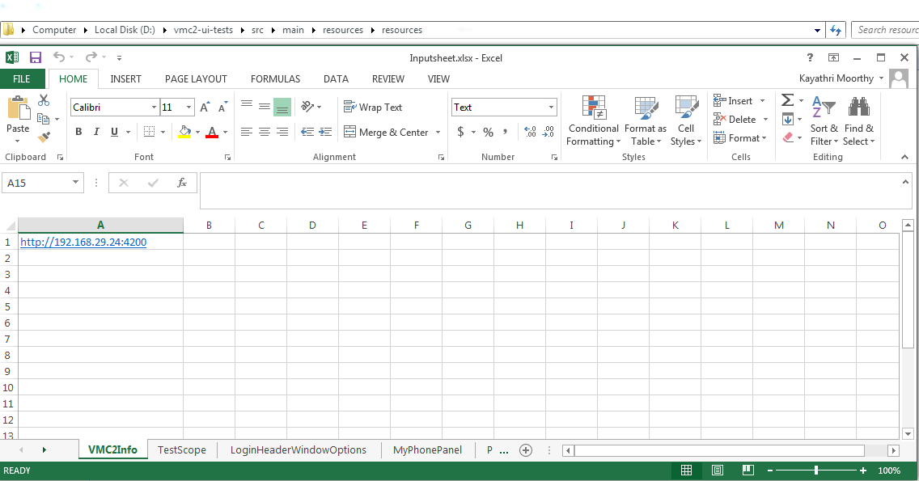

### 2.1.2 TestScope Sheet:

* + TestScope can be configured in TestScope Sheet. Only the modules added in this sheet are tested (useful if you want to test only a single module since running test cases for all modules takes about 30 minutes of time).
  + Following are the list of modules mentioned in TestScope sheet
    - LoginHeaderWindowOptions
    - MyPhonePanel
    - PhoneGroupMenu
    - CorporateDirectory
    - CallLog
    - PhoneObject
    - PhoneGroupObject
    - Settings
    - ParkingLots
    - CallQueues
    - Voicemail
    - CallQueueAgents

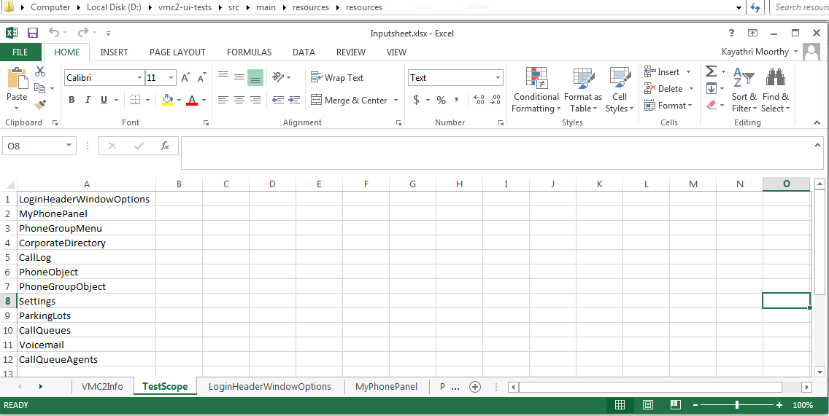

* + Modules mentioned can be removed/added based on user Testcase.
  + Once changes are done, Save the InputSheet.

### 2.1.3 Description of Columns in InputSheet:

* Each Module Sheet has the Following Columns in it For Ex: Open **LoginHeaderWindowOptions** sheet)
* **Browser** – Mention the Browser Name to launch the Test Scripts (CHROME, IE, and FIREFOX).
* **Value** - Mention the ID or Class name value of a particular Element.
* **Type**- Mention its type (ID or CLASSNAME).
* **Action**-Mention the Action to be performed by the Element
* **Data**- Mention the Data required to perform an Action specified for the Element
* **PrerequestType** – Mention the type of a PrerequestData
* **PrerequestData**-Specifies the data to be present mandatory to do the action specified.
* **ID**- Test case Description
* **Scenario**- Scenarios covered for the Test case mentioned in ID.
* **Description**- Description of the Action performed by the Element.
* **Results-** Results will be generated in the Report once the Test Scripts are automated.

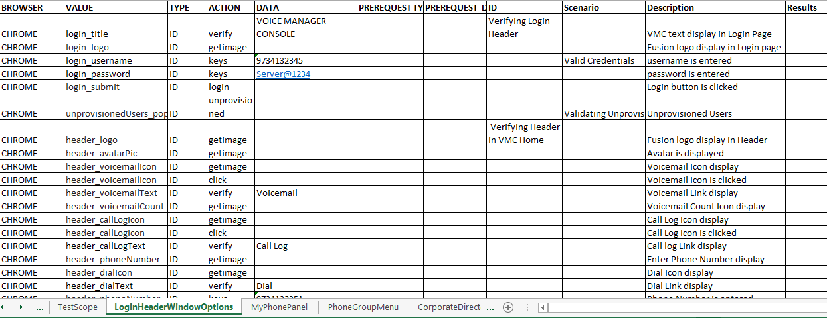

# 3. Installation – Linux:

## 3.1 Steps to install maven in Linux (Ubuntu):

* Make sure JDK is installed and JAVA_HOME, environment variable and path variable is configured.
* Use the following command to verify Java is installed.

Command: **java -version**

* Following message will be displayed when java is present.

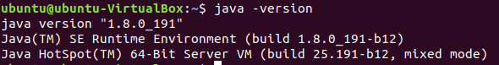

* Use the following command to install maven.

Command: **sudo apt install maven**

Note 1: It may prompt for a password, use the appropriate account password.

Note 2: If the terminal prompts “Do you want to continue” (y or n), enter y to continue installation.

* Use the following command to verify Maven is installed.

Command: **mvn –version**

* Following message will be displayed when maven is installed.

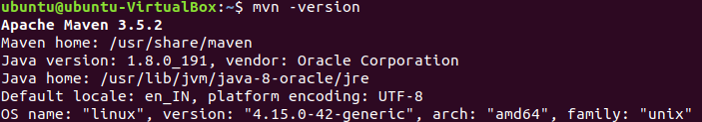

## 3.2 Steps to Build the Application in Terminal :

* Traverse to the path where vmc2-ui-tests folder is present.
* Use the following command to build maven project.

Command: **mvn clean package**

* Command Prompt will prompt a “**Build Success”** message after the successful build.
* Traverse to the below path in vmc2-ui-tests folder.

**Path**: target\drivers\chromedriver

* Use the following command to access driver (Read&write&executable)

Command: chmod 777 chromedriver

* Now driver is ready to execute test scripts.

## 3.3 Steps to Run Application :

* Traverse to the below path in vmc2-ui-tests folder.

**Path**: target\vmc2-0.0.1-SNAPSHOT-jar-with-dependencies.jar

* Use the following Command to run

Command: **java -jar vmc2-0.0.1-SNAPSHOT-jar-with-dependencies.jar**

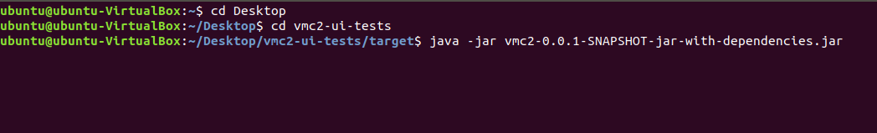

* Test Scripts start running, monitor the Test Scripts through Terminal.
* While execution of Test Scripts, for each module a new instance of browser will be opened.
* Avoid manual Interactions with the browser or terminal where Test scripts are running.

## 3.4 Steps to view Reports and Screenshots in Linux:

* Wait until the message “**output file written”** display in console.
* Traverse to the below path in vmc2-ui-tests folder.

**Path:** target\reports\

* **To view the screenshots captured:**
* Traverse to the below path in vmc2-ui-tests folder.

**Path:** target\screenshots\

## 3.5 Browser and Web Driver Information:

* Firefox Browser – Version 63.0
* Download Link for GeckoDriver:

<https://github.com/mozilla/geckodriver/releases/download/v0.23.0/geckodriver-v0.23.0-linux64.tar.gz>

* Gecko driver – Version 0.23.0
* Chrome Browser – Version 70.1
* Download Link for ChromeDriver:

<https://chromedriver.storage.googleapis.com/2.36/chromedriver_linux64.zip>

* chromedriver – Version 2.36



# 4. Installation – Windows:

## 4.1 Steps to install and configure maven in Windows:

* Make sure JDK is installed and JAVA_HOME, environment variable and path variable is configured.
* Use the following command to verify Java is installed.

Command: **java -version**

* Following message will be displayed when java is present.

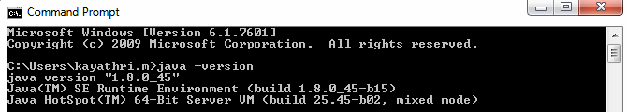

* Download the maven Zip file(apache-maven-3.6.0-bin.zip) from the following link <http://maven.apache.org/download.cgi>
* Unzip it to a Folder
* Press Windows Button and type advanced and click View advanced system settings
* In System Properties dialog, select Advanced tab and clicks on the Environment Variables button.
* In “Environment variables” dialog, System variables, Clicks on the New button and add a MAVEN_HOME variable and point it to the maven folder downloaded.
* Select Path variable and click Edit and add %MAVEN_HOME%\bin after the semicolon.
* Use the following command to verify Maven is installed.

Command: **mvn -version**

* Following message will be displayed when maven is installed.

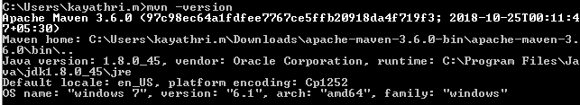

* Command prompt displays the version of the maven installed.

## 4.2 Steps to Build the Application in Command Prompt :

* Traverse to the path where vmc2-ui-tests folder is present.
* Use the following command to build maven project.

Command: **mvn clean package**

* Command Prompt will prompt a “**Build Success”** message after the successful build.

## 4.3 Steps to Run Application :

* Traverse to the below path in vmc2-ui-tests folder.

**Path**: target\vmc2-0.0.1-SNAPSHOT-jar-with-dependencies.jar

* Use the following Command to run

Command: **java -jar vmc2-0.0.1-SNAPSHOT-jar-with-dependencies.jar**

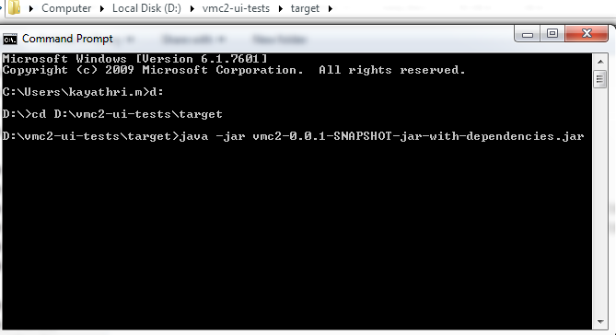

Screenshot: 1.3

* Test Scripts start running, monitor the Test Scripts through Terminal.
* While execution of Test Scripts, for each module a new instance of browser will be opened.
* Avoid manual Interactions with the browser or terminal where Test scripts are running.

## 4.4 Steps to view Reports and Screenshots:

* Wait until the message “**output file written”** display in console.
* Traverse to the below path in vmc2-ui-tests folder.

**Path:** target\reports\

* **To view the screenshots captured:**
* Traverse to the below path in vmc2-ui-tests folder.

**Path:** target\screenshots\

## 4.5 Browser and Web Driver Information:

* Chrome Browser – Version 70.0
* chromedriver – Version 2.36
* Download Link for chromedriver: <https://chromedriver.storage.googleapis.com/2.36/chromedriver_win32.zip>
* Internet Explorer Browser – Version 11.0
* IEDriver –Version 3.8.0
* Download Link for IEDriver:

<https://goo.gl/AtHQuv>

* Firefox Browser –Version 63.3
* Download Link for GeckoDriver:

<https://github.com/mozilla/geckodriver/releases/download/v0.23.0/geckodriver-v0.23.0-win64.zip>

* Gecko driver – Version 0.23.0